Lectures notes

on

Mechanics of Solids

By D Jena

**Module 1**

**Lecture 1**

**Stress**

Stress is the internal resistance offered by the body to the external load applied to it per unit cross sectional area. Stresses are normal to the plane to which they act and are tensile or compressive in nature.

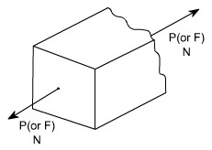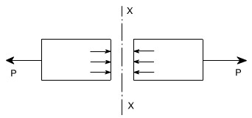

As we know that in mechanics of deformable solids, externally applied forces acts on a body and body suffers a deformation. From equilibrium point of view, this action should be opposed or reacted by internal forces which are set up within the particles of material due to cohesion. These internal forces give rise to a concept of stress. Consider a rectangular rod subjected to axial pull P. Let us imagine that the same rectangular bar is assumed to be cut into two halves at section *XX*. The each portion of this rectangular bar is in equilibrium under the action of load P and the internal forces acting at the section *XX* has been shown.

Now stress is defined as the force intensity or force per unit area. Here we use a symbol to represent the stress.



Where A is the area of the *X –X* section

Here we are using an assumption that the total force or total load carried by the rectangular bar is uniformly distributed over its cross – section. But the stress distributions may be for from uniform, with local regions of high stress known as stress concentrations. If the force carried by a component is not uniformly distributed over its cross – sectional area, A, we must consider a small area, ‘δA’ which carries a small load ‘δP’, of the total force ‘P', Then definition of stress is



As a particular stress generally holds true only at a point, therefore it is defined mathematically as



**Units :**

The basic units of stress in S.I units i.e. (International system) are N / m2 (or Pa)

MPa = 106 Pa

GPa = 109 Pa

KPa = 103 Pa

Sometimes N / mm2 units are also used, because this is an equivalent to MPa. While US customary unit is pound per square inch psi.

**TYPES OF STRESSES :** Only two basic stresses exists : (1) normal stress and (2) shear stress. Other stresses either are similar to these basic stresses or are a combination of this e.g. bending stress is a combination tensile, compressive and shear stresses. Torsional stress, as encountered in twisting of a shaft is a shearing stress. Let us define the normal stresses and shear stresses in the following sections.

**Normal stresses :** We have defined stress as force per unit area. If the stresses are normal to the areas concerned, then these are termed as normal stresses. The normal stresses are generally denoted by a Greek letter (σ)

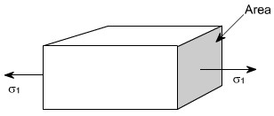

This is also known as uniaxial state of stress, because the stresses acts only in one direction however, such a state rarely exists, therefore we have biaxial and triaxial state of stresses where either the two mutually perpendicular normal stresses acts or three mutually perpendicular normal stresses acts as shown in the figures below :

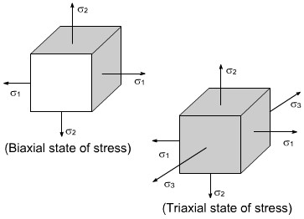

**Tensile or compressive Stresses:**

The normal stresses can be either tensile or compressive whether the stresses acts out of the area or into the area

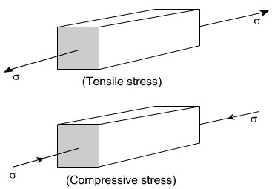

**Bearing Stress:** When one object presses against another, it is referred to a bearing stress ( They are in fact the compressive stresses ).

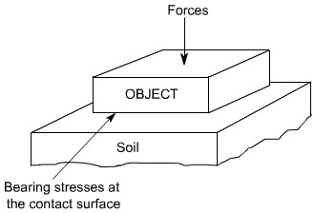

**Sign convections for Normal stress**

Direct stresses or normal stresses

- tensile +ve - compressive –ve

**Shear Stresses:**

Let us consider now the situation, where the cross – sectional area of a block of material is subject to a distribution of forces which are parallel, rather than normal, to the area concerned. Such forces are associated with a shearing of the material, and are referred to as shear forces. The resulting stress is known as shear stress.

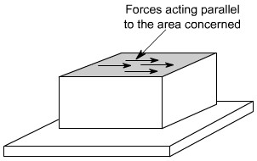

The resulting force intensities are known as shear stresses, the mean shear stress being equal to



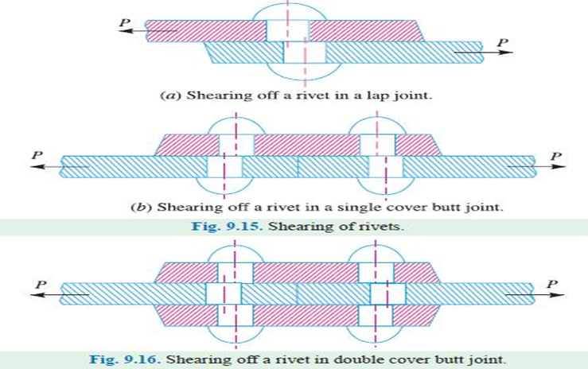

Where P is the total force and A the area over which it acts. As we know that the particular stress generally holds good only at a point therefore we can define shear stress at a point as



The Greek symbol (tau, suggesting tangential) is used to denote shear stress.

**Complementary shear stresses:**

The existence of shear stresses on any two sides of the element induces complementary shear stresses on the other two sides of the element to maintain equilibrium. As shown in the figure the shear stress in sides AB and CD induces a complimentary shear stress ' in sides AD and BC.

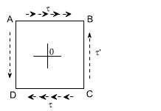

**Sign convections for shear stresses:**

* tending to turn the element C.W +ve.
* tending to turn the element C.C.W – ve.

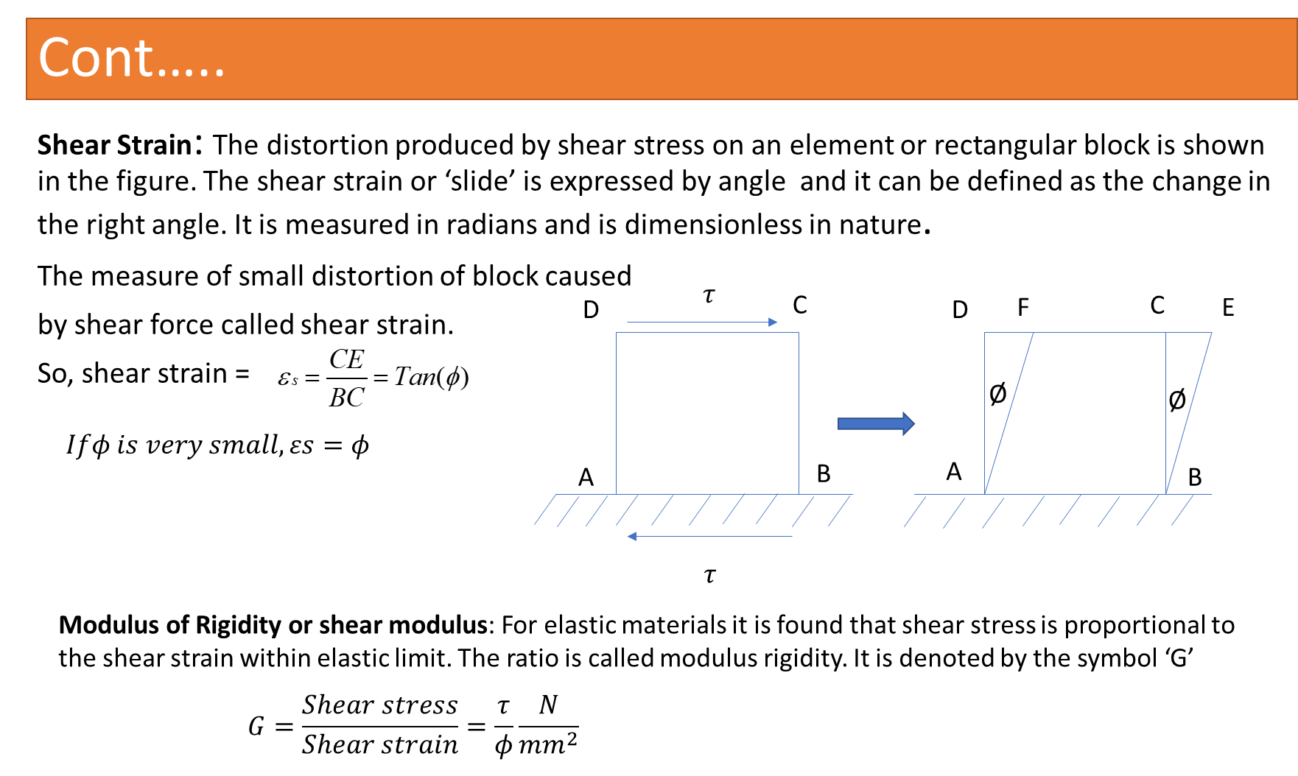

**Deformation of a Body due to Self Weight**

Consider a bar AB hanging freely under its own weight as shown in the figure.

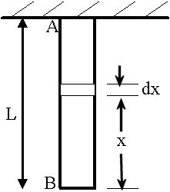

Let

L= length of the bar

A= cross-sectional area of the bar E= Young’s modulus of the bar material w= specific weight of the bar material

Then deformation due to the self-weight of the bar is



**Members in Uni – axial state of stress**

**Introduction:** [For members subjected to uniaxial state of stress]

For a prismatic bar loaded in tension by an axial force P, the elongation of the bar can be determined as

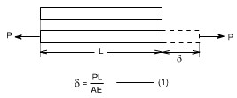

Suppose the bar is loaded at one or more intermediate positions, then equation (1) can be readily adapted to handle this situation, i.e. we can determine the axial force in each part of the bar i.e. parts AB, BC, CD, and calculate the elongation or shortening of each part separately, finally, these changes in lengths can be added algebraically to obtain the total charge in length of the entire bar.

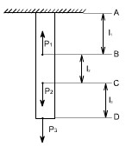

When either the axial force or the cross – sectional area varies continuosly along the axis of the bar, then equation (1) is no longer suitable. Instead, the elongation can be found by considering a deferential element of a bar and then the equation (1) becomes

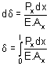

i.e. the axial force Pxand area of the cross – section Ax must be expressed as functions of x. If the expressions for Pxand Ax are not too complicated, the integral can be evaluated analytically, otherwise Numerical methods or techniques can be used to evaluate these integrals.

**Principle of Superposition**

The principle of superposition states that when there are numbers of loads are acting together on an elastic material, the resultant strain will be the sum of individual strains caused by each load acting separately.

**Module 1**

**Lecture 2:**

Numerical Problems on stress, shear stress in axially loaded members.

**Example 1:** Now let us for example take a case when the bar tapers uniformly from d at x = 0 to D at x = l

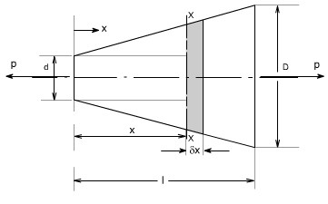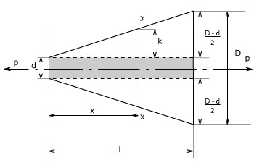

In order to compute the value of diameter of a bar at a chosen location let us determine the value of dimension k, from similar triangles

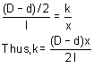

therefore, the diameter 'y' at the X-section is or = d + 2k



Hence the cross –section area at section X- X will be

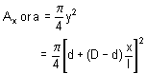

hence the total extension of the bar will be given by expression

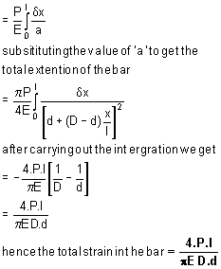

An interesting problem is to determine the shape of a bar which would have a uniform stress in it under the action of its own weight and a load P.

**Example 2: stresses in Non – Uniform bars**

Consider a bar of varying cross section subjected to a tensile force P as shown below.

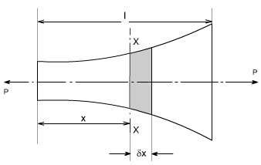

Let

a = cross sectional area of the bar at a chosen section XX then

Stress = p / a

If E = Young's modulus of bar then the strain at the section XX can be calculated



Then the extension of the short element x. =

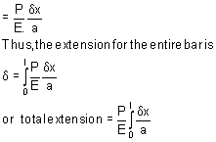

let us consider such a bar as shown in the figure below:

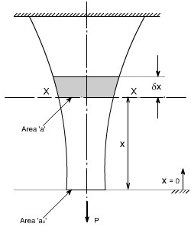

The weight of the bar being supported under section XX is

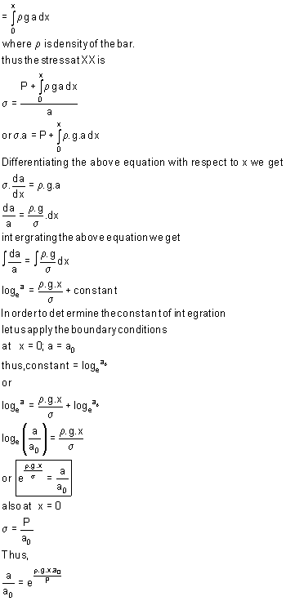

**Example 1:** Calculate the overall change in length of the tapered rod as shown in figure below. It carries a tensile load of 10kN at the free end and at the step change in section a compressive load of 2 MN/m evenly distributed around a circle of 30 mm diameter take the value of E = 208 GN / m2.

This problem may be solved using the procedure as discussed earlier in this section

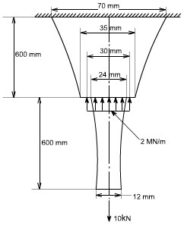

**Example 2:** A round bar, of length L, tapers uniformly from radius r1 at one end to radius r2at the other. Show that the extension produced by a tensile axial load P

is

If r2 = 2r1 , compare this extension with that of a uniform cylindrical bar having a radius equal to the mean radius of the tapered bar.

**Solution:**

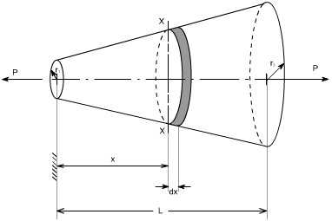

consider the above figure let r1 be the radius at the smaller end. Then at a X crosssection XX located at a distance x from the smaller end, the value of radius is equal to

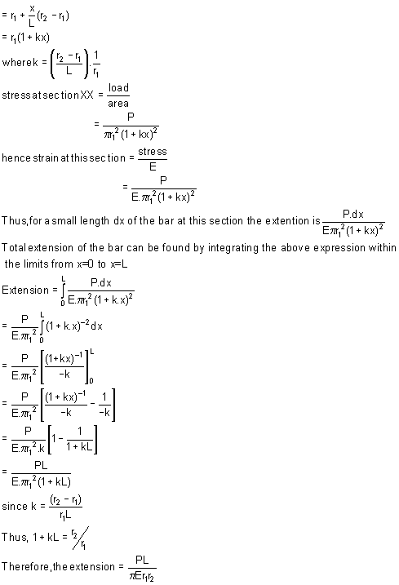

**Comparing of extensions**

For the case when r2 = 2.r1, the value of computed extension as above

becomes equal to



The mean radius of taper bar

= 1 / 2( r1 + r2 )

= 1 / 2( r1 +2 r2 )

= 3 / 2 .r1

Therefore, the extension of uniform bar

= Orginal length . strain

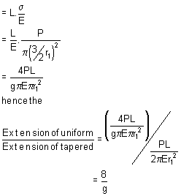

**Module 1Lecture3:**

**Strain:**

When a single force or a system force acts on a body, it undergoes some deformation. This deformation per unit length is known as strain. Mathematically strain may be defined as deformation per unit length.

So,

Strain=Elongation/Original length

Or, 

**Elasticity;**

The property of material by virtue of which it returns to its original shape and size upon removal of load is known as elasticity.

**Hooks Law**

It states that within elastic limit stress is proportional to strain. Mathematically

*Stress*

E=

*Strain*

Where E = Young’s Modulus

Hooks law holds good equally for tension and compression.

**Poisson’s Ratio;**

The ratio lateral strain to longitudinal strain produced by a single stress is known as Poisson’s ratio. Symbol used for poisson’s ratio is µ or 1/ *m*.

**Modulus of Elasticity (or Young’s Modulus)**

Young’s modulus is defined as the ratio of stress to strain within elastic limit.

**Deformation of a body due to load acting on it**

*Stress*

We know that young’s modulus E= ,

*Strain*

Or, strain, 

Now, strain, 

So, deformation 

**Module 1**

**Lecture 4:**  Numerical problems on Stress-strain relationship, Hooke’s law, Poisson’s ratio, shear stress

**Module 1**

**Lecture 5:** Shear strain, modulus of rigidity, bulk modulus. Relationship between material properties of isotropic materials.

**Shear Strain**

The distortion produced by shear stress on an element or rectangular block is shown in the figure. The shear strain or ‘slide’ is expressed by angle ϕ and it can be defined as the change in the right angle. It is measured in radians and is dimensionless in nature.

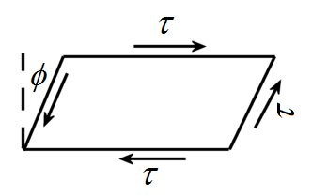

**Modulus of Rigidity**

For elastic materials it is found that shear stress is proportional to the shear strain within elastic limit. The ratio is called modulus rigidity. It is denoted by the symbol ‘G’ or ‘C’.



**Bulk modulus (K):**  It is defined as the ratio of uniform stress intensity to the volumetric strain. It is denoted by the symbol K.





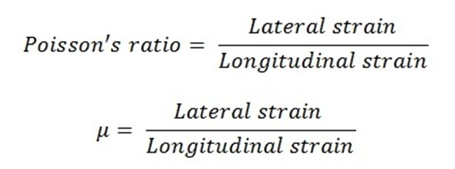

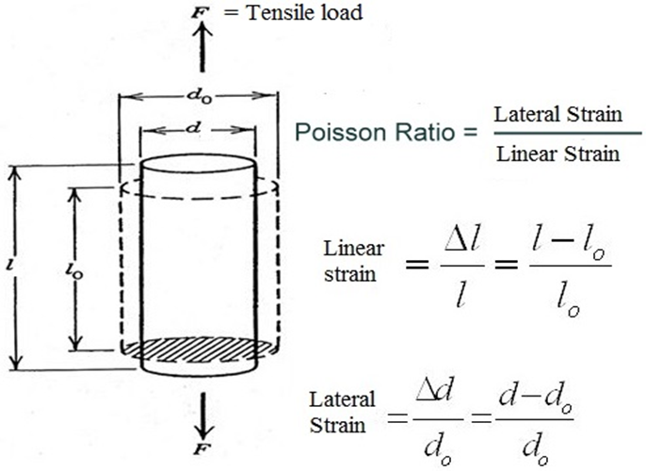

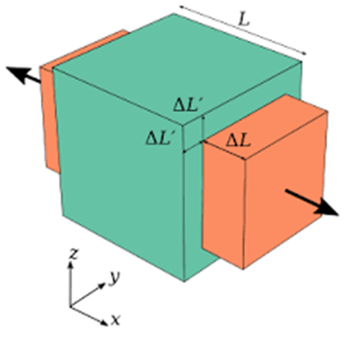

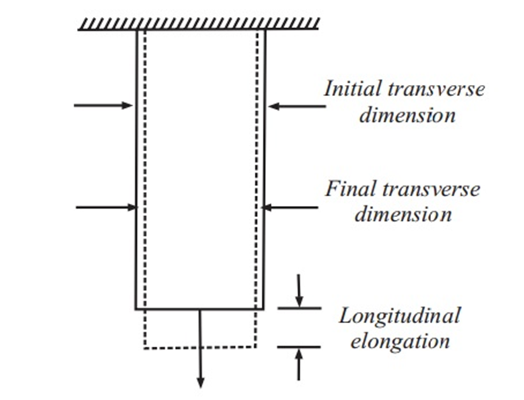

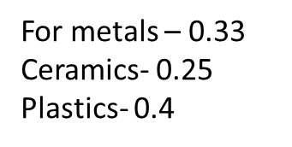

**Relation between elastic constants:**

**Elastic constants:** These are the relations which determine the deformations produced by a given stress system acting on a particular material. These factors are constant within elastic limit, and known as modulus of elasticity *E*, modulus of rigidity *G*, Bulk modulus *K* and Poisson’s ratio *μ.*

**Relationship between modulus of elasticity (E) and bulk modulus (K):**

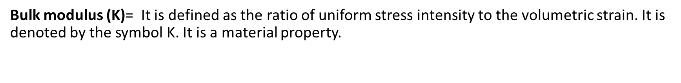



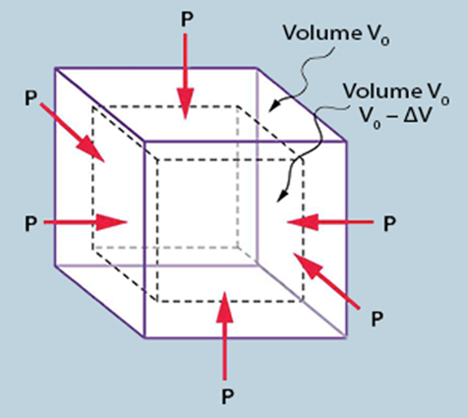

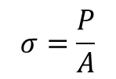

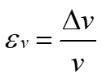

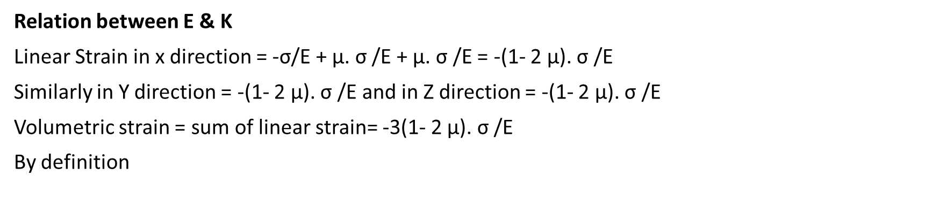

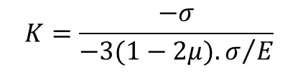



**Relationship between modulus of elasticity (E) and modulus of rigidity (G):**

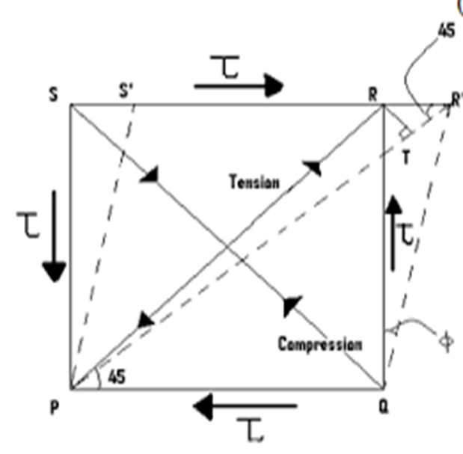

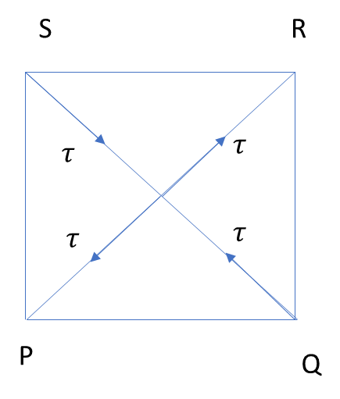

**Linear strain of diagonal PR**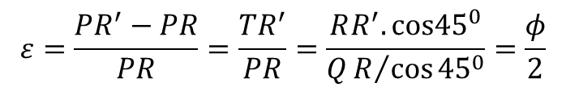

But

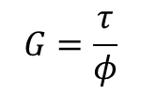

So

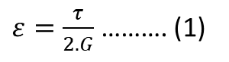

Also the linear strain of diagonal PR



From equation 1, and 2

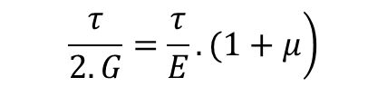



**Relation among three elastic constants:**

We know

$$\begin{matrix}⇒(1+μ)=\frac{E}{2G} \\ \end{matrix}$$

$$\left.E=2G(1+μ\right)$$

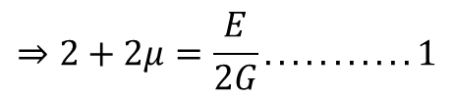

Similarly, as

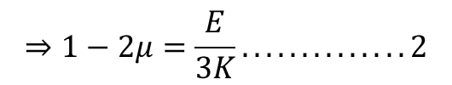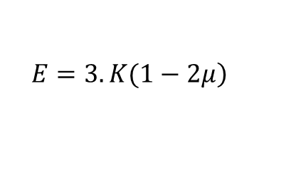

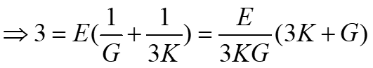 Adding equation 1 and 2

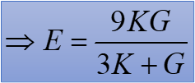

**Module 1:**

**Lecture 6:**

Numerical problems on, relation between elastic constant

**Module 1:**

**Lecture 7:** Stress-strain diagram for uniaxial loading of ductile and brittle materials.

**Stress – Strain Relationship**

**Stress – strain diagram for mild steel**

Standard specimen are used for the tension test.

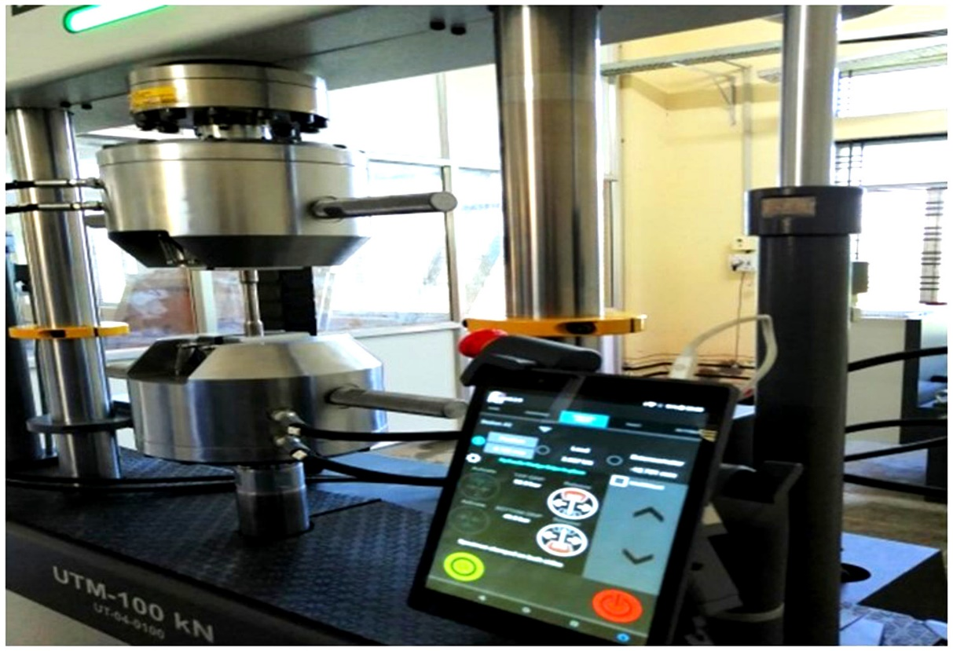

Model- BISS -100 KN Static and dynamic type

There are two types of standard specimen's which are generally used for this purpose, which have been shown below:

**Specimen I:**

This specimen utilizes a circular X-section.

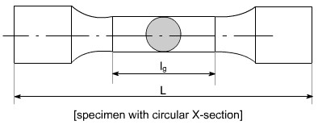

**Specimen II:**

This specimen utilizes a rectangular X-section.

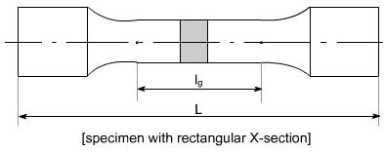

lg = gauge length i.e. length of the specimen on which we want to determine the mechanical properties.The uniaxial tension test is carried out on tensile testing machine and the following steps are performed to conduct this test.

1. The ends of the specimen are secured in the grips of the testing machine.
2. There is a unit for applying a load to the specimen with a hydraulic or mechanical drive.
3. There must be some recording device by which you should be able to measure the final output in the form of Load or stress. So the testing machines are often equipped with the pendulum type lever, pressure gauge and hydraulic capsule and the stress Vs strain diagram is plotted which has the following shape. A typical tensile test curve for the mild steel has been shown below

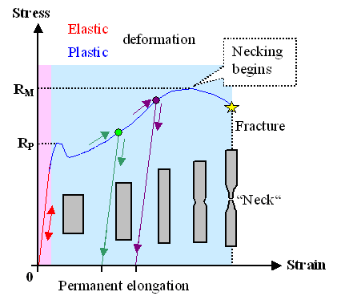

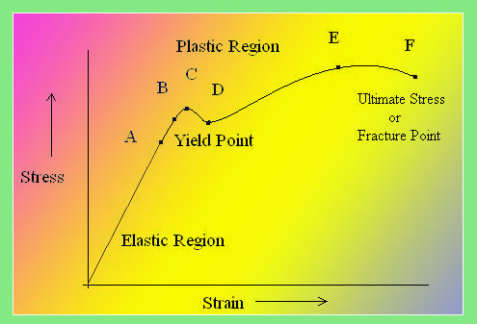

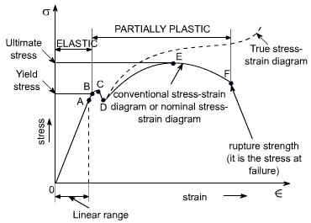

**SALIENT POINTS OF THE GRAPH:**

1. So it is evident form the graph that the strain is proportional to strain or elongation is proportional to the load giving a st.line relationship. This law of proportionality is valid upto a point A.

or we can say that point A is some ultimate point when the linear nature of the graph ceases or there is a deviation from the linear nature. This point is known as **the limit of proportionality or the proportionality limit**.

1. For a short period beyond the point A, the material may still be elastic in the sense that the deformations are completely recovered when the load is removed. The limiting point B is termed as **Elastic Limit** .
2. **and (D)** - Beyond the elastic limit plastic deformation occurs and strains are not totally recoverable. There will be thus permanent deformation or permanent set when load is removed. These two points are termed as upper and lower yield points respectively. The stress at the yield point is called the yield strength.

A study a stress – strain diagrams shows that the yield point is so near the proportional limit that for most purpose the two may be taken as one. However, it is much easier to locate the former. For material which do not posses a well define yield points, In order to find the yield point or yield strength, an offset method is applied.

In this method a line is drawn parallel to the straight line portion of initial stress diagram by off setting this by an amount equal to 0.2% of the strain as shown as below and this happens especially for the low carbon steel.

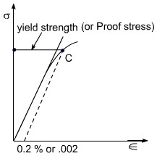

1. A further increase in the load will cause marked deformation in the whole volume of the metal. The maximum load which the specimen can with stand without failure is called the load at the ultimate strength.

The highest point ‘E' of the diagram corresponds to the ultimate strength of a material.

su = Stress which the specimen can with stand without failure & is known as Ultimate Strength or Tensile Strength.

su is equal to load at E divided by the original cross-sectional area of the bar.

1. Beyond point E, the bar begins to forms neck. The load falling from the maximum until fracture occurs at F. Beyond point E, the cross-sectional area of the specimen begins to reduce rapidly over a relatively small length of bar and the bar is said to form a neck. This necking takes place whilst the load reduces, and fracture of the bar finally occurs at point F.

**Nominal stress – Strain OR Conventional Stress – Strain diagrams:**

Stresses are usually computed on the basis of the original area of the specimen; such stresses are often referred to as conventional or nominal stresses.

**True stress – Strain Diagram:**

Since when a material is subjected to a uniaxial load, some contraction or expansion always takes place. Thus, dividing the applied force by the corresponding actual area of the specimen at the same instant gives the so called true stress.

**Percentage Elongation: 'd ':**

The ductility of a material in tension can be characterized by its elongation and by the reduction in area at the cross section where fracture occurs.

It is the ratio of the extension in length of the specimen after fracture to its initial gauge length, expressed in percentage.



lI = gauge length of specimen after fracture(or the distance between the gage marks at fracture)

lg= gauge length before fracture(i.e. initial gauge length)

For 50 mm gage length, steel may here a % elongation d of the order of 10% to 40%.

**Ductile and Brittle Materials:**

Based on this behaviour, the materials may be classified as ductile or brittle materials

**Ductile Materials:**

It we just examine the earlier tension curve one can notice that the extension of the materials over the plastic range is considerably in excess of that associated with elastic loading. The Capacity of materials to allow these large deformations or large extensions without failure is termed as ductility. The materials with high ductility are termed as ductile materials.

**Brittle Materials:**

A brittle material is one which exhibits a relatively small extensions or deformations to fracture, so that the partially plastic region of the tensile test graph is much reduced.

This type of graph is shown by the cast iron or steels with high carbon contents or concrete.

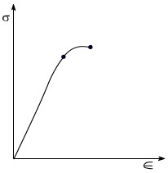

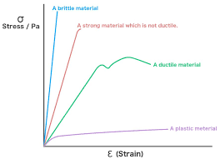

**Factor of Safety**

* Experimental and Design value of strength of a material
* Generally stress is calculated from the knowledge of:
* Magnitude and position of load
* Dimension of the member
* Properties of material and also environmental conditions
* Application of Hook’s law

$$F.S=\frac{Ultimate stress}{maximum permissible or workingstress}$$

$$F.S=\frac{yield stress}{maximum permissible orworking stress}$$

Approximations and Assumptions

* Load:
* Dimension and Surface finish
* Character of materials
* Ambient conditions
* Hooks law
* For dead or gradually applied load up to 3 and for shock load = 12

**Module 1:**

**Lecture 8:** Introduction to mechanical properties of metals-hardness, impact

**Mechanical Properties of material:**

Elasticity: Property of material by virtue of which it can regain its shape after removal of external load

Plasticity: Property of material by virtue of which, it will be in a state of permanent deformation even after removal of external load.

Ductility: Property of material by virtue of which, the material can be drawn into wires.

Hardness: Property of material by virtue of which the material will offer resistance to penetration or indentation.

**Ball indentation Tests:**

This method consists in pressing a hardened steel ball under a constant load P into a specially prepared flat surface on the test specimen as indicated in the figures below :

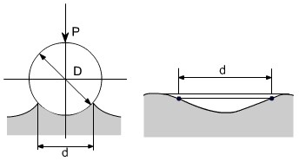

After removing the load an indentation remains on the surface of the test specimen. If area of the spherical surface in the indentation is denoted as F sq. mm.

Brinell Hardness number is defined as :

BHN = P / F

F is expressed in terms of D and d

D = ball diameter

d = diametric of indentation and Brinell Hardness number is given by



Then is there is also **Vicker's Hardness Number** in which the ball is of conical shape.

**IMPACT STRENGTH**

Static tension tests of the unnotched specimen's do not always reveal the susceptibility of metal to brittle fracture. This important factor is determined in impact tests. In impact tests we use the notched specimen's



this specimen is placed on its supports on anvil so that blow of the striker is opposite to the notch the impact strength is defined as the energy A, required to rupture the specimen,

Impact Strength = A / f

Where f = It is the cross – section area of the specimen in cm2 at fracture & obviously at notch.

The impact strength is a complex characteristic which takes into account both toughness and strength of a material. The main purpose of notched – bar tests is to study the simultaneous effect of stress concentration and high velocity load application

Impact test are of the severest type and facilitate brittle friction. Impact strength values can not be as yet be used for design calculations but these tests as rule provided for in specifications for carbon & alloy steels.Futher, it may be noted that in impact tests fracture may be either brittle or ductile. In the case of brittle fracture, fracture occurs by separation and is not accompanied by noticeable plastic deformation as occurs in the case of ductile fracture.

**Impact loads:**

Considering a weight falling from a height h, on to a collar attached at the end as shown in the figure.

Let P= equivalent static or gradually applied load which will produce the same extension x as that of the impact load W

Neglecting loss of energy due to impact, we can have:

Loss of potential energy= gain of strain energy of the bar



Now we have extension 

Substituting the value of x in the above equation we have:



Solving the above equation we can have the following relation:



Important Case: for a particular case i.e. for h=0, for a suddenly applied load P=2W,

i.e. the stress produced by a suddenly applied load is twice that of the static stress.

**Numerical examples:**

Q1. Referring to the following figure let a mass of 100 kg fall 4cm on to a collar attached to a bar of steel 2cm diameter, 3m long. Find the maximum stress set up.

Take E= 205,000 N/mm2.

Q2.

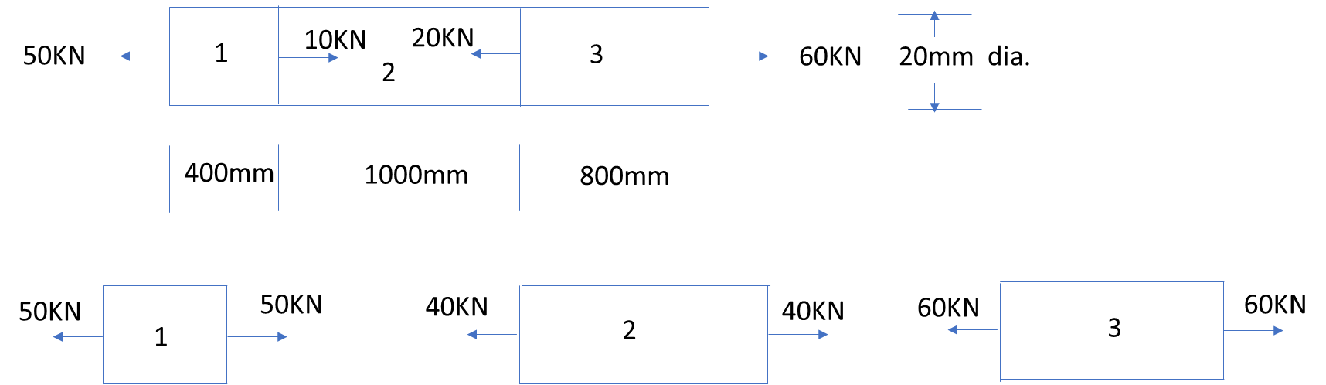

Total strain= strain in( part 1 + part 2+ part 3)

Stress(1)= 50 KN/A1, Stress (2)= 40KN/A2, Stress(3)= 60KN/A3

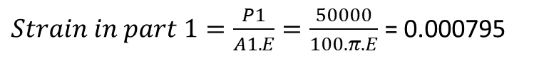

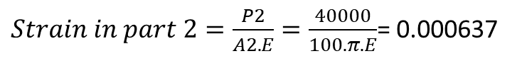

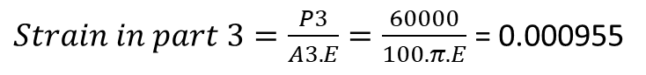



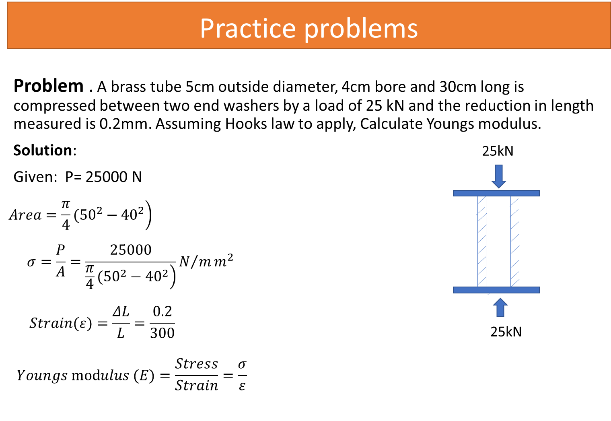

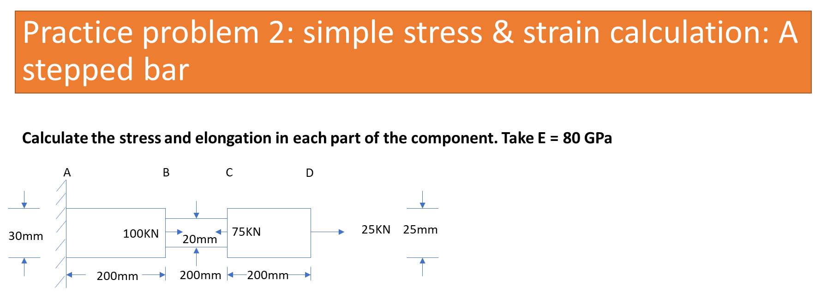

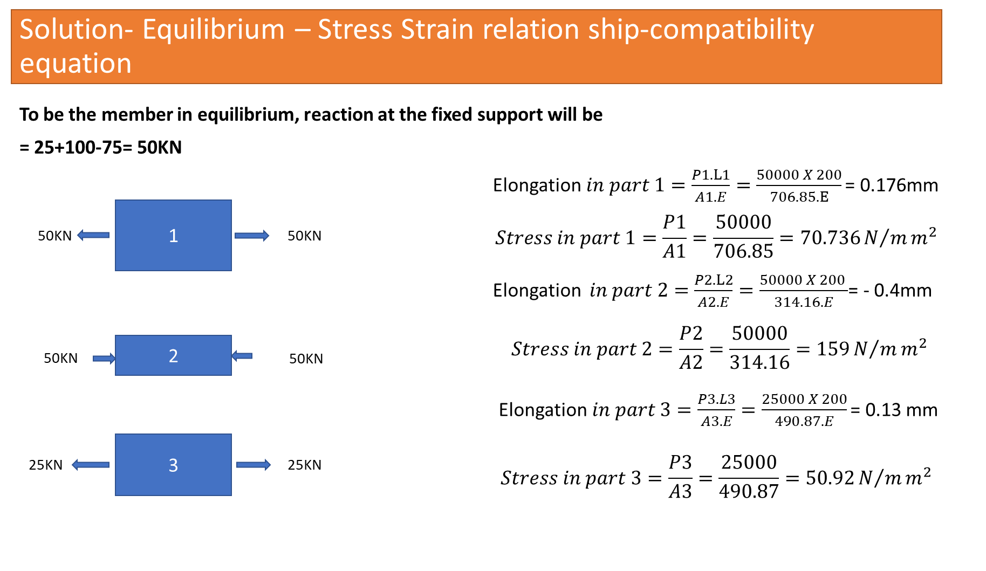

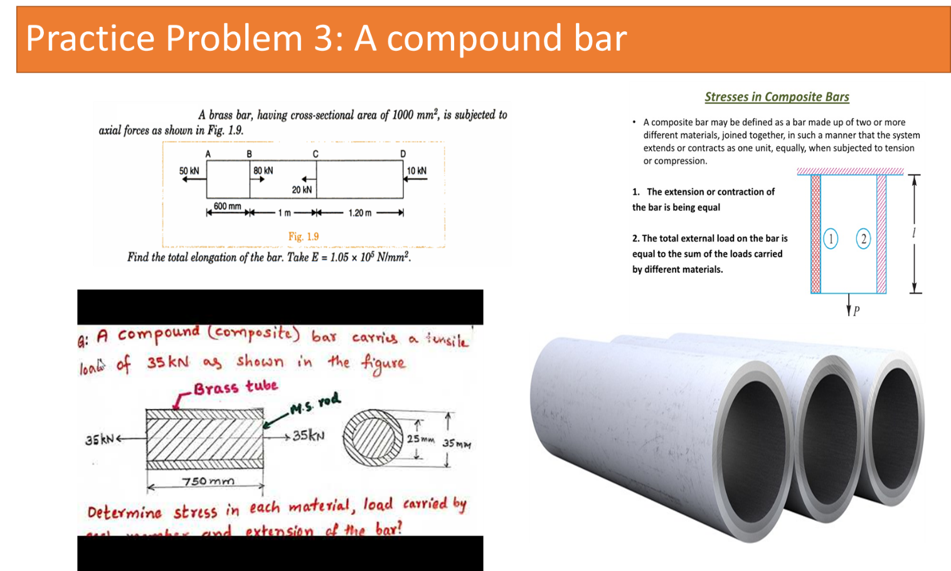

**Practice Problem**

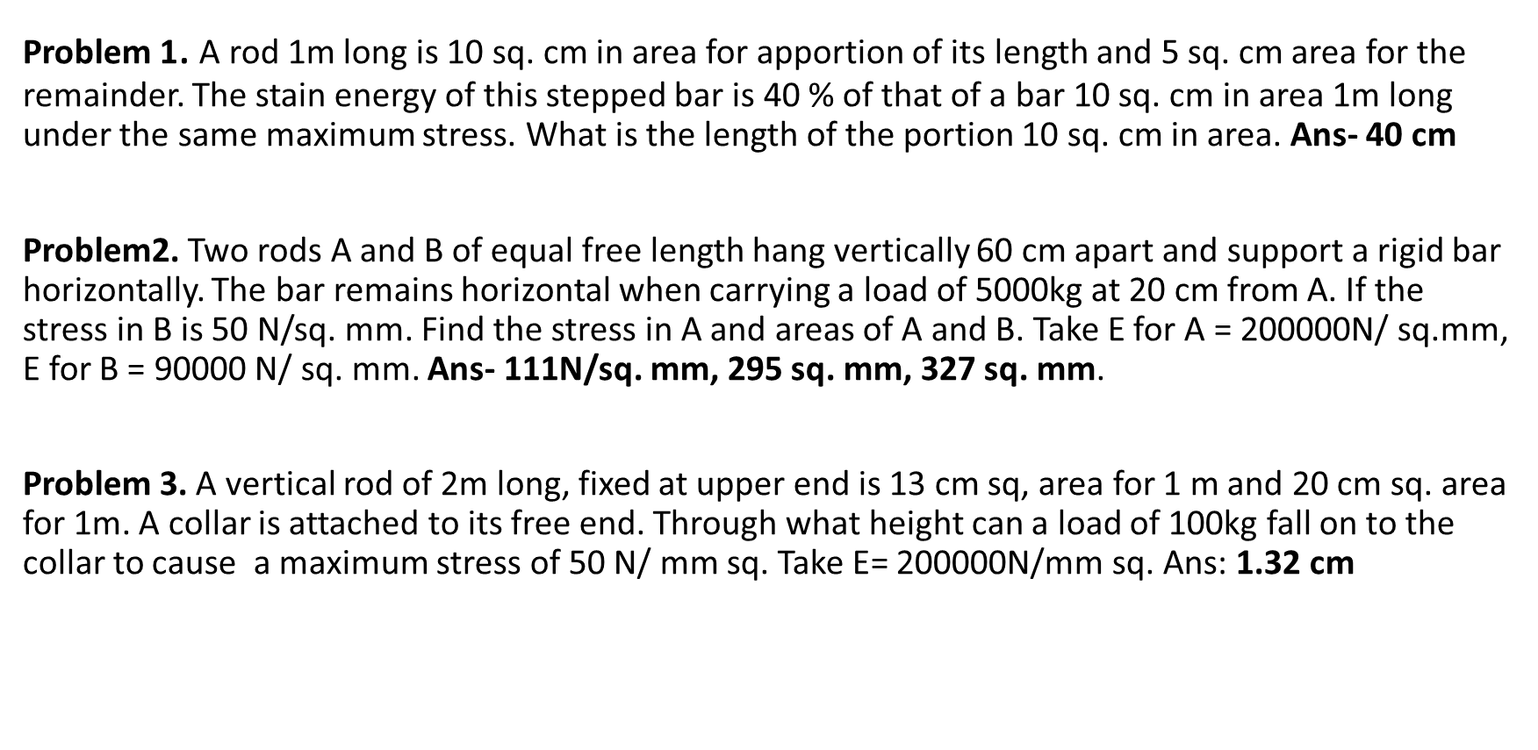

**Module 1:**

**Lecture 9:Composite Bars In Tension & Compression**:-Temperature stresses in composite rods statically indeterminate problem.

**Thermal stresses, Bars subjected to tension and Compression**

**Compound bar:** In certain application it is necessary to use a combination of elements or bars made from different materials, each material performing a different function. In over head electric cables or Transmission Lines for example it is often convenient to carry the current in a set of copper wires surrounding steel wires. The later being designed to support the weight of the cable over large spans. Such a combination of materials is generally termed compound bars.

Consider therefore, a compound bar consisting of n members, each having a different length and cross sectional area and each being of a different material. Let all member have a common extension ‘x' i.e. the load is positioned to produce the same extension in each member.

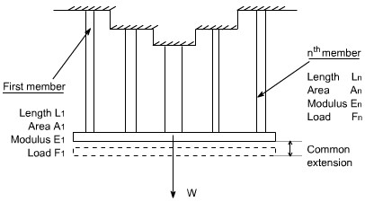

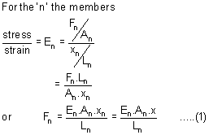

Where Fn is the force in the nth member and An and Ln are its cross - sectional area and length.

Let W be the total load, the total load carried will be the sum of all loads for all the members.

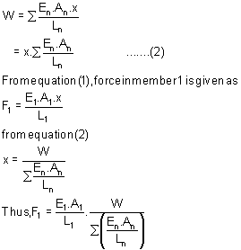

Therefore, each member carries a portion of the total load W proportional of EA / L value.

The above expression may be writen as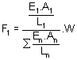

if the length of each individual member in same then, we may write

Thus, the stress in member '1' may be determined as 1 = F1 / A1

**Determination of common extension of compound bars:** In order to determine the common extension of a compound bar it is convenient to consider it as a single bar of an imaginary material with an equivalent or combined modulus Ec.

**Assumption:** Here it is necessary to assume that both the extension and original lengths of the individual members of the compound bar are the same, the strains in all members will than be equal.

Total load on compound bar = F1 + F2+ F3 +………+ Fn where F1 , F 2 ,….,etc are the loads in members 1,2 etc

But force = stress . area,therefore

⬧ (A 1 + A 2 + ……+ A n ) = 1A1 + 2A2 + ........+ *n* An

Where  is the stress in the equivalent single bar

Dividing throughout by the common strain .

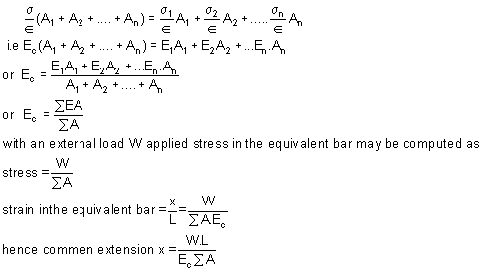

**Compound bars subjected to Temp. Change :** Ordinary materials expand when heated and contract when cooled, hence , an increase in temperature produce a positive thermal strain. Thermal strains usually are reversible in a sense that the member returns to its original shape when the temperature return to its original value. However, there here are some materials which do not behave in this manner. These metals differs from ordinary materials in a sence that the strains are related non linearly to temperature and some times are irreversible .when a material is subjected to a change in temp. is a length will change by an amount.



Or 



α = coefficient of linear expansion for the material L = original Length t = temp. change

Thus an increase in temperature produces an increase in length and a decrease in temperature results in a decrease in length except in very special cases of materials with zero or negative coefficients of expansion which need not to be considered here.

If however, the free expansion of the material is prevented by some external force, then a stress is set up in the material. They stress is equal in magnitude to that which would be produced in the bar by initially allowing the bar to its free length and then applying sufficient force to return the bar to its original length.

Change in Length = α L t

Therefore, strain = α L t / L

= αt

Therefore, the stress generated in the material by the application of sufficient force to remove this strain = strain x E or Stress = E α t

Consider now a compound bar constructed from two different materials rigidly joined together, for simplicity.

Let us consider that the materials in this case are steel and brass.

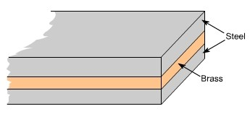

If we have both applied stresses and a temp. change, thermal strains may be added to those given by generalized hook's law equation –e.g.

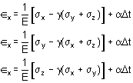

While the normal strains a body are affected by changes in temperatures, shear strains are not. Because if the temp. of any block or element changes, then its size changes not its shape therefore shear strains do not change.

In general, the coefficients of expansion of the two materials forming the compound bar will be different so that as the temp. rises each material will attempt to expand by different amounts. Figure below shows the positions to which the individual materials will expand if they are completely free to expand (i.e not joined rigidly together as a compound bar). The extension of any Length L is given by L t

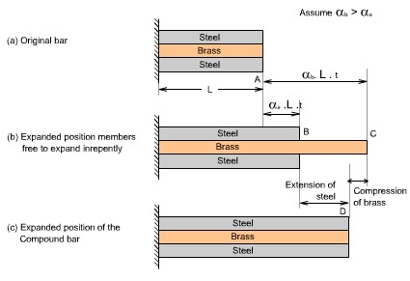

In general, changes in lengths due to thermal strains may be calculated form equation , provided that the members are able to expand or contract freely, a situation that exists in statically determinates structures. As a consequence no stresses are generated in a statically determinate structure when one or more members undergo a uniform temperature change. If in a structure (or a compound bar), the free expansion or contraction is not allowed then the member becomes s statically indeterminate, which is just being discussed as an example of the compound bar and thermal stresses would be generated.

If the two materials are now rigidly joined as a compound bar and subjected to the same temp. rise, each materials will attempt to expand to its free length position but each will be affected by the movement of the other. The higher coefficient of expansion material (brass) will therefore, seek to pull the steel up to its free length position and conversely, the lower coefficient of expansion martial (steel) will try to hold the brass back. In practice a compromised is reached, the compound bar extending to the position shown in fig (c), resulting in an effective compression of the brass from its free length position and an effective extension of steel from its free length position.

**Module 1:**

**Lecture 10:**

**Two Dimensional State of Stress and Strain**: Principal stresses. Numerical examples

**Stresses on oblique plane:**Till now we have dealt with either pure normal direct stress or pure shear stress. In many instances, however both direct and shear stresses acts and the resultant stress across any section will be neither normal nor tangential to the plane. A plane stse of stress is a 2 dimensional stae of stress in a sense that the stress components in one direction are all zero i.e



Examples of plane state of stress include plates and shells. Consider the general case of a bar under direct load F giving rise to a stress y vertically

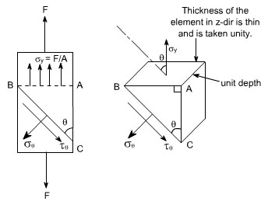

The stress acting at a point is represented by the stresses acting on the faces of the element enclosing the point. The stresses change with the inclination of the planes passing through that point i.e. the stress on the faces of the element vary as the angular position of the element changes. Let the block be of unit depth now considering the equilibrium of forces on the triangle portion ABC. Resolving forces perpendicular to BC, gives .BC.1 = σy sin. AB.1 but AB/BC = sinθ or AB = BC sinθ

Substituting this value in the above equation, we get

.BC.1 = σy sin θ. BC sinθ . 1 or =σ*y* sin2 2θ (1)

**Now resolving the forces parallel to BC**

.BC.1 = σy cos θ. AB sin θ. 1

again AB = BC cos θ

.BC.1 = σy cos θ. BC sin θ.1 or =σy sinθ cosθ

=½ σ*y .*sin2θ (2)

If  = 900 the BC will be parallel to AB and = 0, i.e. there will be only direct stress or normal stress.

By examining the equations (1) and (2), the following conclusions may be drawn (i) The value of direct stressis maximum and is equal to σy when v= 900.

(ii) The shear stress  has a maximum value of 0.5 σy when θ= 450

**Material subjected to pure shear:**

Consider the element shown to which shear stresses have been applied to the sides AB and DC

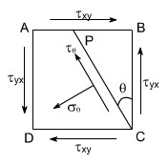

Complementary shear stresses of equal value but of opposite effect are then set up on the sides AD and BC in order to prevent the rotation of the element. Since the applied and complementary shear stresses are of equal value on the x and y planes. Therefore, they are both represented by the symbol τxy.

Now consider the equilibrium of portion of PBC

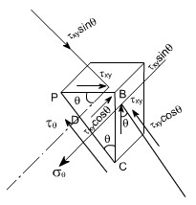

Assuming unit depth and resolving normal to PC or in the direction of 

.PC.1 =τ*xy* .PB.cosθ.1+τ*xy* .BC.sinθ.1

=τ*xy* .PB.cos + τ*xy* .BC.sin

Now writing PB and BC in terms of PC so that it cancels out from the two sides PB/PC = sinθ BC/PC = cosθ

.PC.1 = τ*xy* .cosθ. sinθ.PC+τ*xy* .cosθ.sinθ.PC

= 2τ*xy* sinθcosθ

Or, =2τ*xy* sin2θ (1)

Now resolving forces parallel to PC or in the direction of  .then τ*xy* PC.1

= τ*xy* . PB sinθ-τ*xy* BC cosθ

-ve sign has been put because this component is in the same direction as that of  .

again converting the various quantities in terms of PC we have

τ*xy* PC. 1 =τ*xy* . PB.sin2θ.τ*xy* -τ*xy* PCcos2θ

= -τ*xy* [cos2θ- sin2θ] = -τ*xy* cos2θ (2) the negative sign means that the sense of is opposite to that of assumed one. Let us examine the equations (1) and (2) respectively

From equation (1) i.e,

= τ*xy* sin2

The equation (1) represents that the maximum value ofis τ*xy* when θ= 450.Let us take into consideration the equation (2) which states that

= - τ*xy* cos2θ

It indicates that the maximum value of is τ*xy* when θ= 00 or 900. it has a value zero when θ = 450.

From equation (1) it may be noticed that the normal component has maximum and minimum values of + xy (tension) and xy(compression) on plane at ± 450 to the applied shear and on these planes the tangential component is zero.

Hence the system of pure shear stresses produces and equivalent direct stress system, one set compressive and one tensile each located at 450 to the original shear directions as depicted in the figure below:

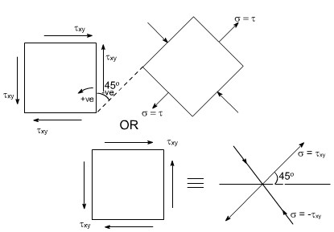

**Material subjected to two mutually perpendicular direct stresses:**

Now consider a rectangular element of unit depth, subjected to a system of two direct stresses both tensile, σx and σyacting right angles to each other.

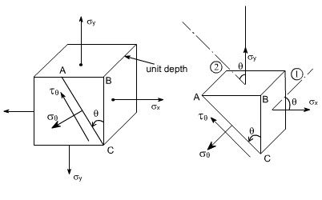

for equilibrium of the portion ABC, resolving perpendicular to AC

AC.1 = σ*y* sin θ. AB.1 + σ*x* cos θ. BC.1 converting AB and BC in terms of AC so that AC cancels out from the sides

 = σ*y* sin2θ+σ*x* cos2θ

Futher, recalling that cos2θ- sin2θ = cos2θ or (1 - cos2θ)/2 = sin2θ

Similarly (1 + cos2θ)/2 = cos2θ

Hence by these transformations the expression for reduces to

= 1/2 σy (1- cos2θ ) + 1/2 σx (1 + cos2θ ) On rearranging the various terms we get

 (3)

Now resolving parallal to AC

.AC.1= σxy..cos θ.AB.1+ σxy.BC.sinθ .1

The – ve sign appears because this component is in the same direction as that of AC.

Again converting the various quantities in terms of AC so that the AC cancels out from the two sides.

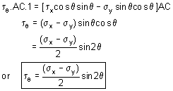 (4)

**Conclusions :**

The following conclusions may be drawn from equation (3) and (4)

1. The maximum direct stress would be equal to σx or σy which ever is the greater, when = 00 or 900
2. The maximum shear stress in the plane of the applied stresses occurs when = 450



**Lecturer 11**

**Material subjected to combined direct and shear stresses:**

Now consider a complex stress system shown below, acting on an element of material.

The stresses σx and σy may be compressive or tensile and may be the result of direct forces or as a result of bending.The shear stresses may be as shown or completely reversed and occur as a result of either shear force or torsion as shown in the figure below:

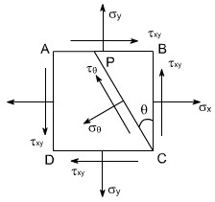

As per the double subscript notation the shear stress on the face BC should be notified as yx , however, we have already seen that for a pair of shear stresses there is a set of complementary shear stresses generated such thatτyx = τxy

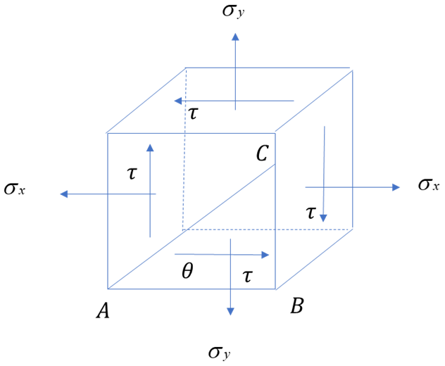

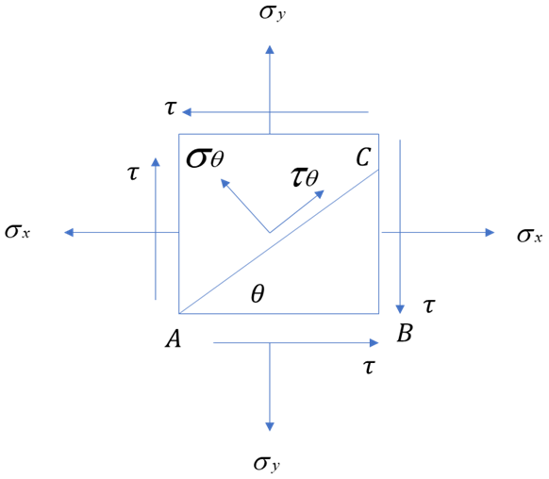

By looking at this state of stress, it may be observed that this state of stress is combination of two different cases:

1. Material subjected to pure stae of stress shear. In this case the various formulas deserved are as follows

= τyx sin2θ

= τyx cos 2θ

1. Material subjected to two mutually perpendicular direct stresses. In this case the various formula's derived are as follows.

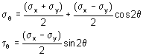

To get the required equations for the case under consideration,let us add the respective equations for the above two cases such that

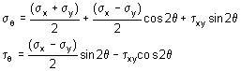

These are the equilibrium equations for stresses at a point. They do not depend on material proportions and are equally valid for elastic and inelastic behaviour

This eqn gives two values of 2 that differ by 1800 .Hence the planes on which maximum and minimum normal stresses occurate 900apart.

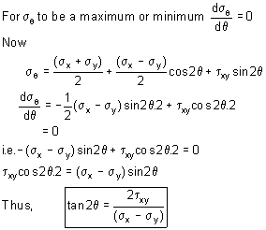

From the triangle it may be determined

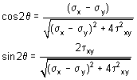

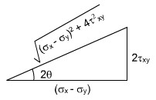

Substituting the values of cos2θ and sin2θ in equation (5) we get

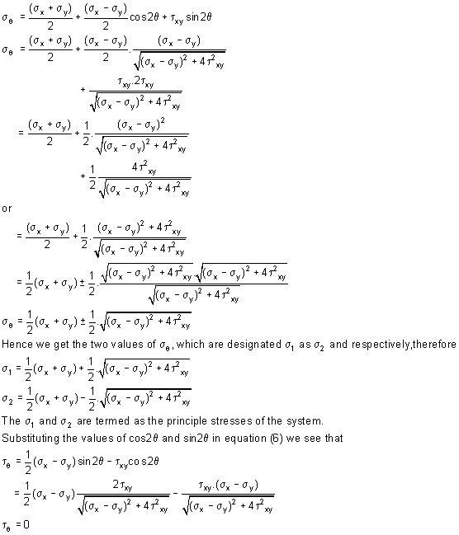

This shows that the values oshear stress is zero on the principal planes.

Hence the maximum and minimum values of normal stresses occur on planes of zero shearing stress. The maximum and minimum normal stresses are called the principal stresses, and the planes on which they act are called principal plane the solution of equation



will yield two values of 2 separated by 1800 i.e. two values of separated by 900 .Thus the two principal stresses occur on mutually perpendicular planes termed principal planes.

Therefore the two – dimensional complex stress system can now be reduced to the equivalent system of principal stresses.

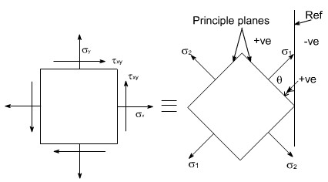

Let us recall that for the case of a material subjected to direct stresses the value of maximum shear stresses

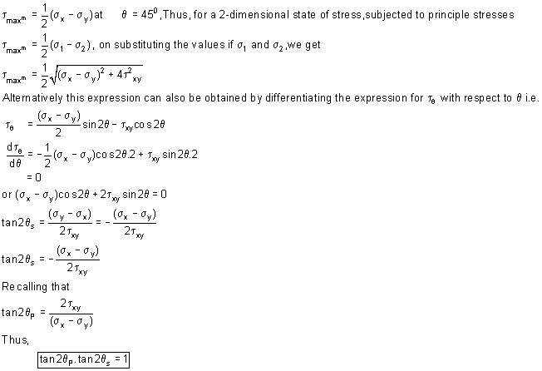

Therefore,it can be concluded that the equation (2) is a negative reciprocal of equation (1) hence the roots for the double angle of equation (2) are 900 away from the corresponding angle of equation (1).

This means that the angles that angles that locate the plane of maximum or minimum shearing stresses form angles of 450 with the planes of principal stresses.

Futher, by making the triangle we get

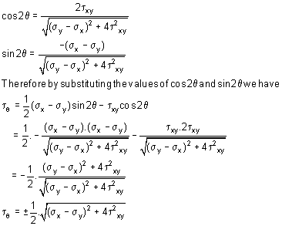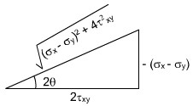

Because of root the difference in sign convention arises from the point of view of locating the planes on which shear stress act. From physical point of view these sign have no meaning.

The largest stress regard less of sign is always know as maximum shear stress.

**Lecturer 12**

**Principal plane inclination in terms of associated principal stress:**

We know that the equation 

yields two values of q i.e. the inclination of the two principal planes on which the principal stresses s1 and s2 act. It is uncertain,however, which stress acts on which plane unless equation.

 is used and observing which one of the

two principal stresses is obtained.

Alternatively we can also find the answer to this problem in the following manner

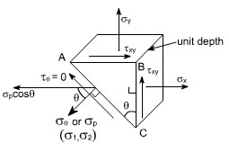

Consider once again the equilibrium of a triangular block of material of unit depth, Assuming AC to be a principal plane on which principal stresses p acts, and the shear stress is zero.

Resolving the forces horizontally we get:

σx .BC . 1 + τxy .AB . 1 =σp . cosθ . AC dividing the above equation through by BC we get

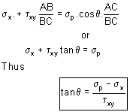

**GRAPHICAL SOLUTION – MOHR'S STRESS CIRCLE**

The transformation equations for plane stress can be represented in a graphical form known as Mohr's circle. This grapical representation is very useful in depending the relationships between normal and shear stresses acting on any inclined plane at a point in a stresses body.

To draw a Mohr's stress circle consider a complex stress system as shown in the figure

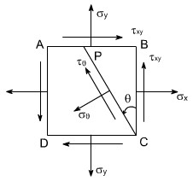

The above system represents a complete stress system for any condition of applied load in two dimensions

The Mohr's stress circle is used to find out graphically the direct stress and sheer stress on any plane inclined at to the plane on which σx acts.The direction of here is taken in anticlockwise direction from the BC.

**STEPS:**

In order to do achieve the desired objective we proceed in the following manner (i) Label the Block ABCD.

1. Set up axes for the direct stress (as abscissa) and shear stress (as ordinate)
2. Plot the stresses on two adjacent faces e.g. AB and BC, using the following sign convention.

Direct stresses tensile positive; compressive, negative

Shear stresses – tending to turn block clockwise, positive

– tending to turn block counter clockwise, negative

[ i.e shearing stresses are +ve when its movement about the centre of the element is clockwise ]

This gives two points on the graph which may than be labeled as  respectively to denote stresses on these planes.

1. Join .
2. The point P where this line cuts the s axis is than the centre of Mohr's stress circle and the line joining  is diameter. Therefore the circle can now be drawn.

Now every point on the circle then represents a state of stress on some plane through C.

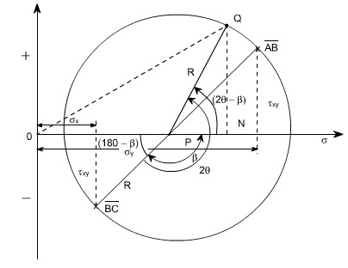

**Proof:**

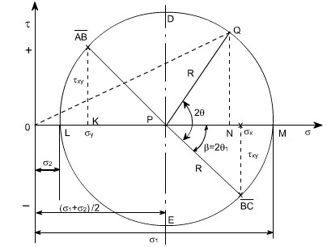

Consider any point Q on the circumference of the circle, such that PQ makes an angle 2 with BC, and drop a perpendicular from Q to meet the s axis at N.Then OQ represents the resultant stress on the plane an angle to BC. Here we have assumed that x y

Now let us find out the coordinates of point Q. These are ON and QN.

From the figure drawn earlier

ON = OP + PN

OP = OK + KP

OP =σy + 1/2 ( σx y)

= y / 2 + y / 2 + x / 2 + y / 2

= ( σx + σy ) / 2

PN = R.cos( 2 )

hence ON = OP + PN

= ( x + y ) / 2 + Rcos( 2 ) = ( x + y ) / 2 + Rcos2 cos + Rsin2 sin now make the substitutions for Rcos and Rsin .



Thus,

ON = 1/2 ( x + y ) + 1/2 ( xy )cos2 + xysin2 (1)

Similarly QM = Rsin( 2 )

= Rsin2 cos - Rcos2 sin

Thus, substituting the values of R cos and Rsin , we get

QM = 1/2 ( xy)sin2 xycos2 (2)

If we examine the equation (1) and (2), we see that this is the same equation which we have already derived analytically

Thus the co-ordinates of Q are the normal and shear stresses on the plane inclined at to BC in the original stress system.

**N.B:** Since angle  PQ is 2 on Mohr's circle and not it becomes obvious that angles are doubled on Mohr's circle. This is the only difference, however, as They are measured in the same direction and from the same plane in both figures.

Further points to be noted are :

1. The direct stress is maximum when Q is at M and at this point obviously the sheer stress is zero, hence by definition OM is the length representing the maximum principal stresses 1 and 2 1 gives the angle of the plane 1 from BC. Similar OL is the other principal stress and is represented by 2
2. The maximum shear stress is given by the highest point on the circle and is represented by the radius of the circle.

This follows that since shear stresses and complimentary sheer stresses have the same value; therefore the centre of the circle will always lie on the s axis midway between x and y . [ since + xy &xy are shear stress & complimentary shear stress so they are same in magnitude but different in sign. ]

1. From the above point the maximum sheer stress i.e. the Radius of the Mohr's stress circle would be



While the direct stress on the plane of maximum shear must be mid – may between x and y i.e



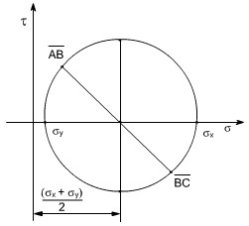

1. As already defined the principal planes are the planes on which the shear components are zero.

Therefore are conclude that on principal plane the sheer stress is zero.

1. Since the resultant of two stress at 900 can be found from the parallogram of vectors as shown in the diagram.Thus, the resultant stress on the plane at q to BC is given by OQ on Mohr's Circle.

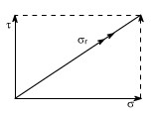

1. The graphical method of solution for a complex stress problems using Mohr's circle is a very powerful technique, since all the information relating to any plane within the stressed element is contained in the single construction. It thus, provides a convenient and rapid means of solution. Which is less prone to arithmetical errors and is highly recommended.

**Lecturer13**

**Numericals:**

Let us discuss few representative problems dealing with complex state of stress to be solved either analytically or graphically.

**Q 1:**

A circular bar 40 mm diameter carries an axial tensile load of 105 kN. What is the Value of shear stress on the planes on which the normal stress has a value of 50 MN/m2 tensile.

**Solution:**

Tensile stress σy= F / A = 105 x 103 / π (0.02)2

= 83.55 MN/m2

Now the normal stress on an obliqe plane is given by the relation

= σysin2θ

50 x 106 = 83.55 MN/m2 x 106sin2θ

= 50068'

The shear stress on the oblique plane is then given by

= 1/2 σysin2θ

= 1/2 x 83.55 x 106 x sin 101.36

= 40.96 MN/m2

Therefore the required shear stress is 40.96 MN/m2

**Q2:**

For a given loading conditions the state of stress in the wall of a cylinder is expressed as follows:

1. 85 MN/m2 tensile
2. 25 MN/m2 tensile at right angles to (a)
3. Shear stresses of 60 MN/m2 on the planes on which the stresses (a) and (b) act; the sheer couple acting on planes carrying the 25 MN/m2 stress is clockwise in effect.

Calculate the principal stresses and the planes on which they act. What would be the effect on these results if owing to a change of loading (a) becomes compressive while stresses (b) and (c) remain unchanged **Solution:**

The problem may be attempted both analytically as well as graphically. Let us first obtain the analytical solution

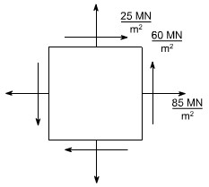

The principle stresses are given by the formula

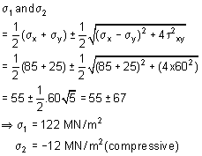

For finding out the planes on which the principle stresses act us the

equation 

The solution of this equation will yeild two values i.e they 1 and 2 giving 1= 31071' &2= 121071'

(b) In this case only the loading (a) is changed i.e. its direction had been changed. While the other stresses remains unchanged hence now the block diagram becomes.

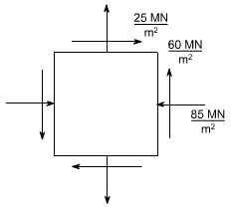

Again the principal stresses would be given by the equation.

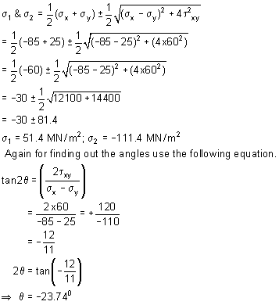

Thus, the two principle stresses acting on the two mutually perpendicular planes i.e principle planes may be depicted on the element as shown below:

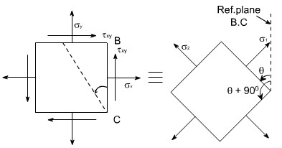

So this is the direction of one principle plane & the principle stresses acting on this would be 1 when is acting normal to this plane, now the direction of other principal plane would be 900 + because the principal planes are the two mutually perpendicular plane, hence rotate the another plane + 900 in the same direction to get the another plane, now complete the material element if is negative that means we are measuring the angles in the opposite direction to the reference plane BC .

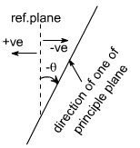

Therefore the direction of other principal planes would be { + 90} since the angle is always less in magnitude then 90 hence the quantity ( + 90 ) would be positive therefore the Inclination of other plane with reference plane would be positive therefore if just complete the Block. It would appear as

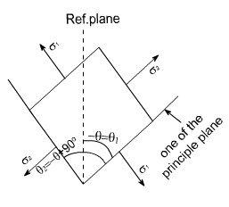

If we just want to measure the angles from the reference plane, than rotate this block through 1800 so as to have the following appearance.

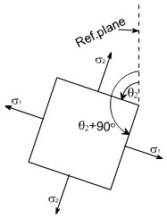

So whenever one of the angles comes negative to get the positive value, first Add 900 to the value and again add 900 as in this case = 23074' so θ1 = 23074' + 900 = 66026' .Again adding 900 also gives the direction of

other principle planes

i.e θ2 = 66026' + 900 = 156026'

This is how we can show the angular position of these planes clearly.

**Lecturer 14**

**GRAPHICAL SOLUTION:**

**Mohr's Circle solution:** The same solution can be obtained using the graphical solution i.e the Mohr's stress circle,for the first part, the block diagram becomes

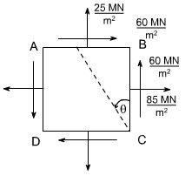

Construct the graphical construction as per the steps given earlier.

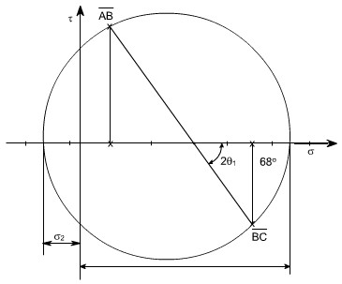

Taking the measurements from the Mohr's stress circle, the various quantities computed are

σ1= 120 MN/m2 tensile

σ2= 10 MN/m2 compressive

θ1= 340 counter clockwise from BC

θ2= 340 + 90 = 1240 counter clockwise from BC

**Part Second :** The required configuration i.e the block diagram for this case is shown along with the stress circle.

By taking the measurements, the various quantites computed are given as

σ1= 56.5 MN/m2 tensile

σ2= 106 MN/m2 compressive

θ1= 66015' counter clockwise from BC

θ2= 156015' counter clockwise from BC **Salient points of Mohr's stress circle:**

1. complementary shear stresses (on planes 900 apart on the circle) are equal in magnitude
2. The principal planes are orthogonal: points L and M are 1800 apart on the circle (900 apart in material)
3. There are no shear stresses on principal planes: point L and M lie on normal stress axis.
4. The planes of maximum shear are 450 from the principal points D and E are 900 , measured round the circle from points L and M.
5. The maximum shear stresses are equal in magnitude and given by points D and E
6. The normal stresses on the planes of maximum shear stress are equal i.e. points D and E both have normal stress co-ordinate which is equal to the two principal stresses.

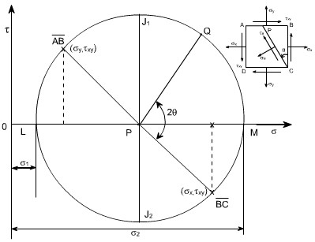

As we know that the circle represents all possible states of normal and shear stress on any plane through a stresses point in a material. Further we have seen that the co-ordinates of the point ‘Q' are seen to be the same as those derived from equilibrium of the element. i.e. the normal and shear stress components on any plane passing through the point can be found using Mohr's circle. Worthy of note:

1. The sides AB and BC of the element ABCD, which are 900 apart, are represented on the circle by and they are 1800 apart.
2. It has been shown that Mohr's circle represents all possible states at a point. Thus, it can be seen at a point. Thus, it, can be seen that two planes LP and PM, 1800 apart on the diagram and therefore 900 apart in the material, on which shear stress is zero. These planes are termed as principal planes and normal stresses acting on them are known as principal stresses.

Thus , σ1 = OL

σ2 = OM

1. The maximum shear stress in an element is given by the top and bottom points of the circle i.e by points J1 and J2 ,Thus the maximum shear stress would be equal to the radius of i.e. Ƭmax= 1/2( 1 2 ),the corresponding normal stress is obviously the distance OP = 1/2 (σx+ σy ) , Further it can also be seen that the planes on which the shear stress is maximum are situated 900 from the principal planes ( on circle ), and 450 in the material.

4.The minimum normal stress is just as important as the maximum. The algebraic minimum stress could have a magnitude greater than that of the maximum principal stress if the state of stress were such that the centre of the circle is to the left of orgin.

i.e. if σ1 = 20 MN/m2 (say) σ2 = 80 MN/m2 (say)

Then Ƭmaxm = (σ1+ σ2 / 2 ) = 50 MN/m2

If should be noted that the principal stresses are considered a maximum or minimum mathematically e.g. a compressive or negative stress is less than a positive stress, irrespective or numerical value.

5. Since the stresses on perpendular faces of any element are given by the coordinates of two diametrically opposite points on the circle, thus, the sum of the two normal stresses for any and all orientations of the element is constant, i.e. Thus sum is an invariant for any particular state of stress.

Sum of the two normal stress components acting on mutually perpendicular planes at a point in a state of plane stress is not affected by the orientation of these planes.

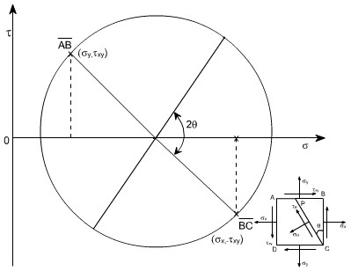

This can be also understand from the circle Since AB and BC are diametrically opposite thus, what ever may be their orientation, they will always lie on the diametre or we can say that their sum won't change, it can also be seen from analytical relations

We know 

on plane BC; = 0

σn1 = σx

on plane AB; = 2700

σn2 = σy

Thus σn1 +σn2= σx+σy

1. If σ1 = σ2, the Mohr's stress circle degenerates into a point and no shearing stresses are developed on xy plane.
2. If σx+ σy= 0, then the center of Mohr's circle coincides with the origin of co-ordinates.